# **Week 6 Mandatory Hands On Outputs**

**REACT JS HOL 1**

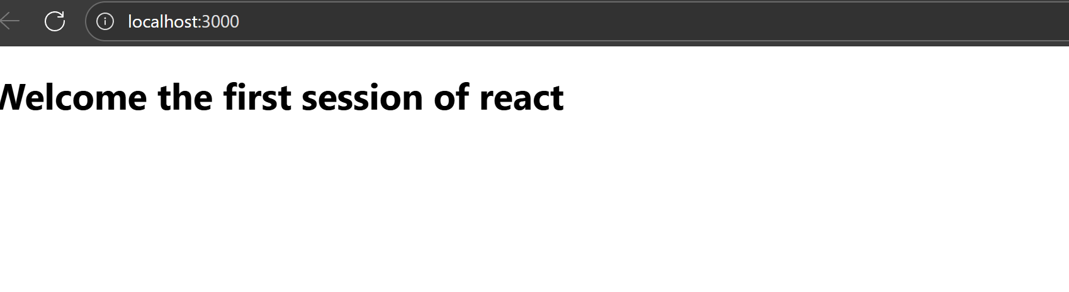

**REACT JS HOL 2**

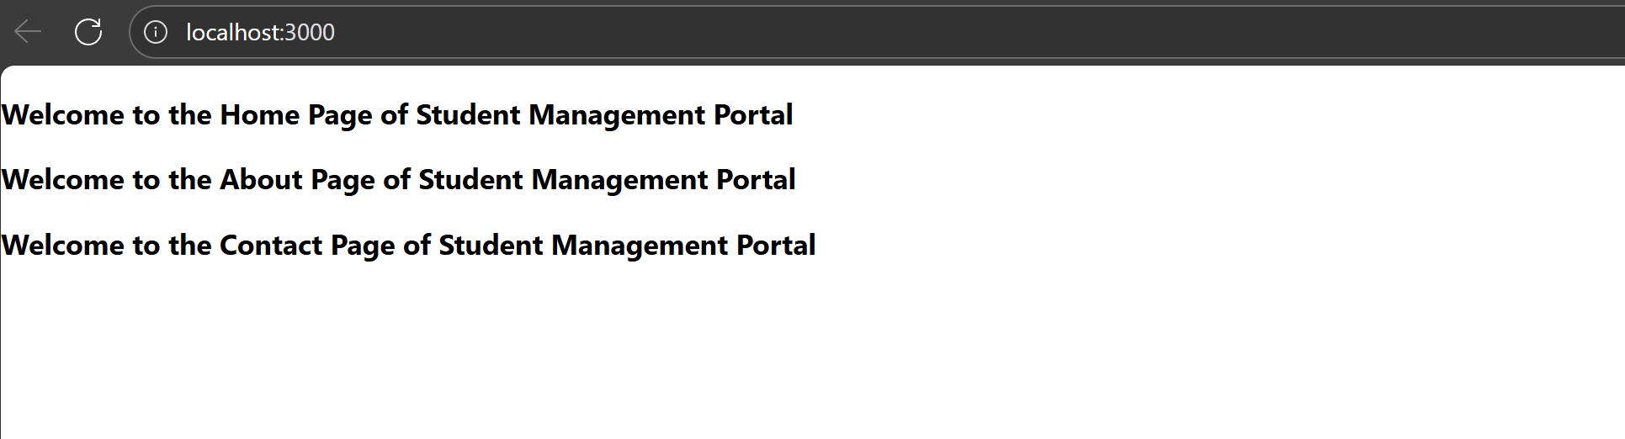

**REACT JS HOL 3**

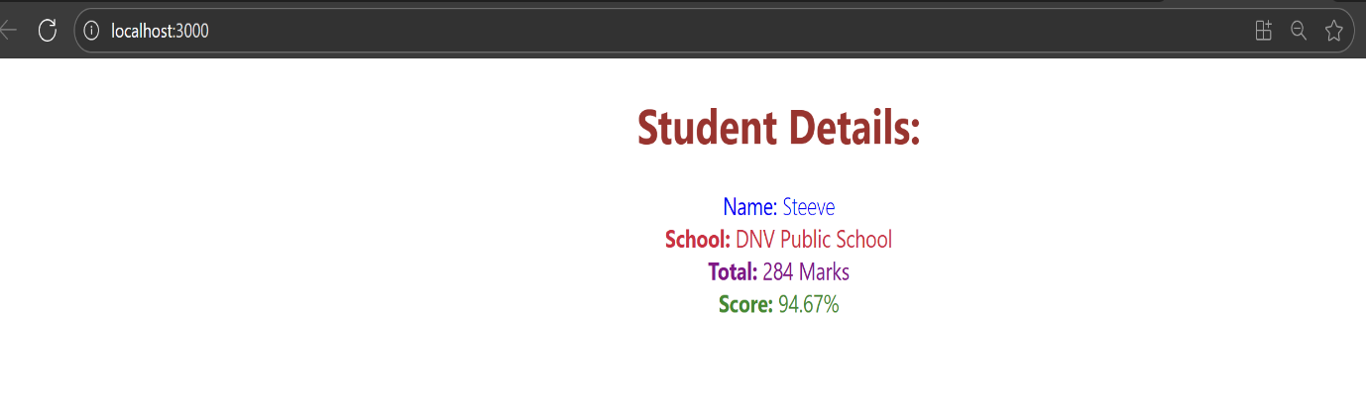

**REACT JS HOL 4**

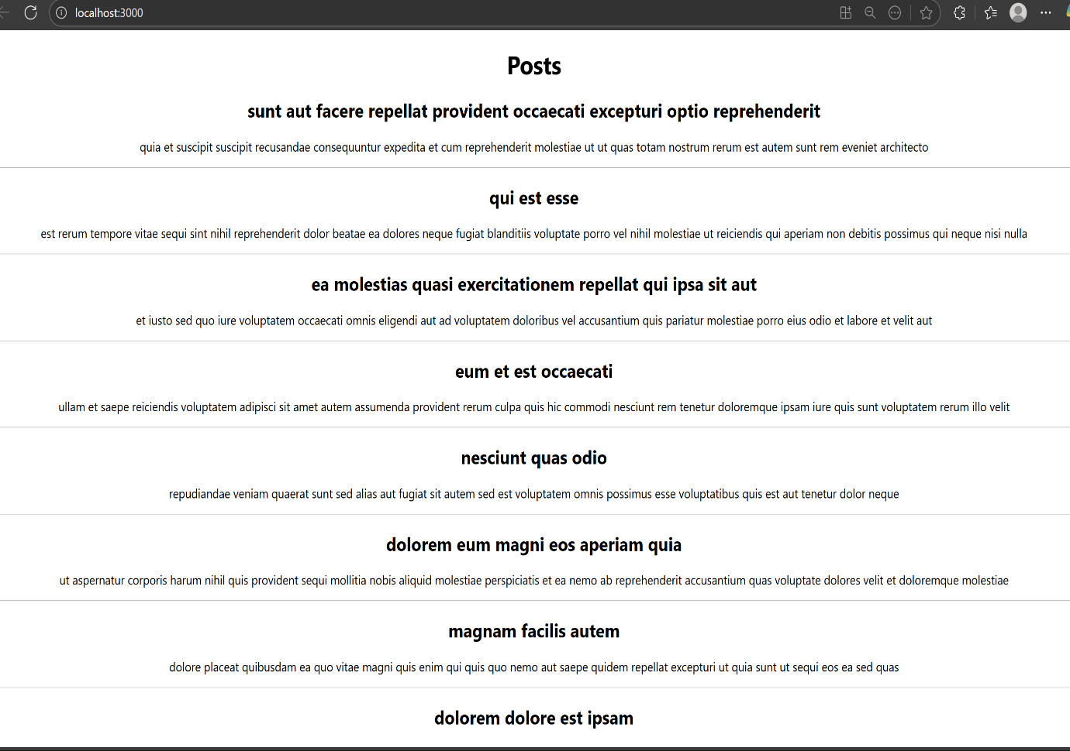

**REACT JS HOL 5**

